Spalding University for undergraduate and masters in Religious Studies.

Certificate completion for Catechetical Ministries Archdiocese of Louisville and Boston Spiritual Institute.

2012 Religious Educators Excellence Award.

Enjoy golfing, traveling with friends, family vacations, and spending time at the beach reading. Love Christmas.

Influenced by the SCN’s (love of Christ impels us) and Thomas Merton
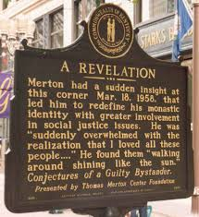

Quotes:

